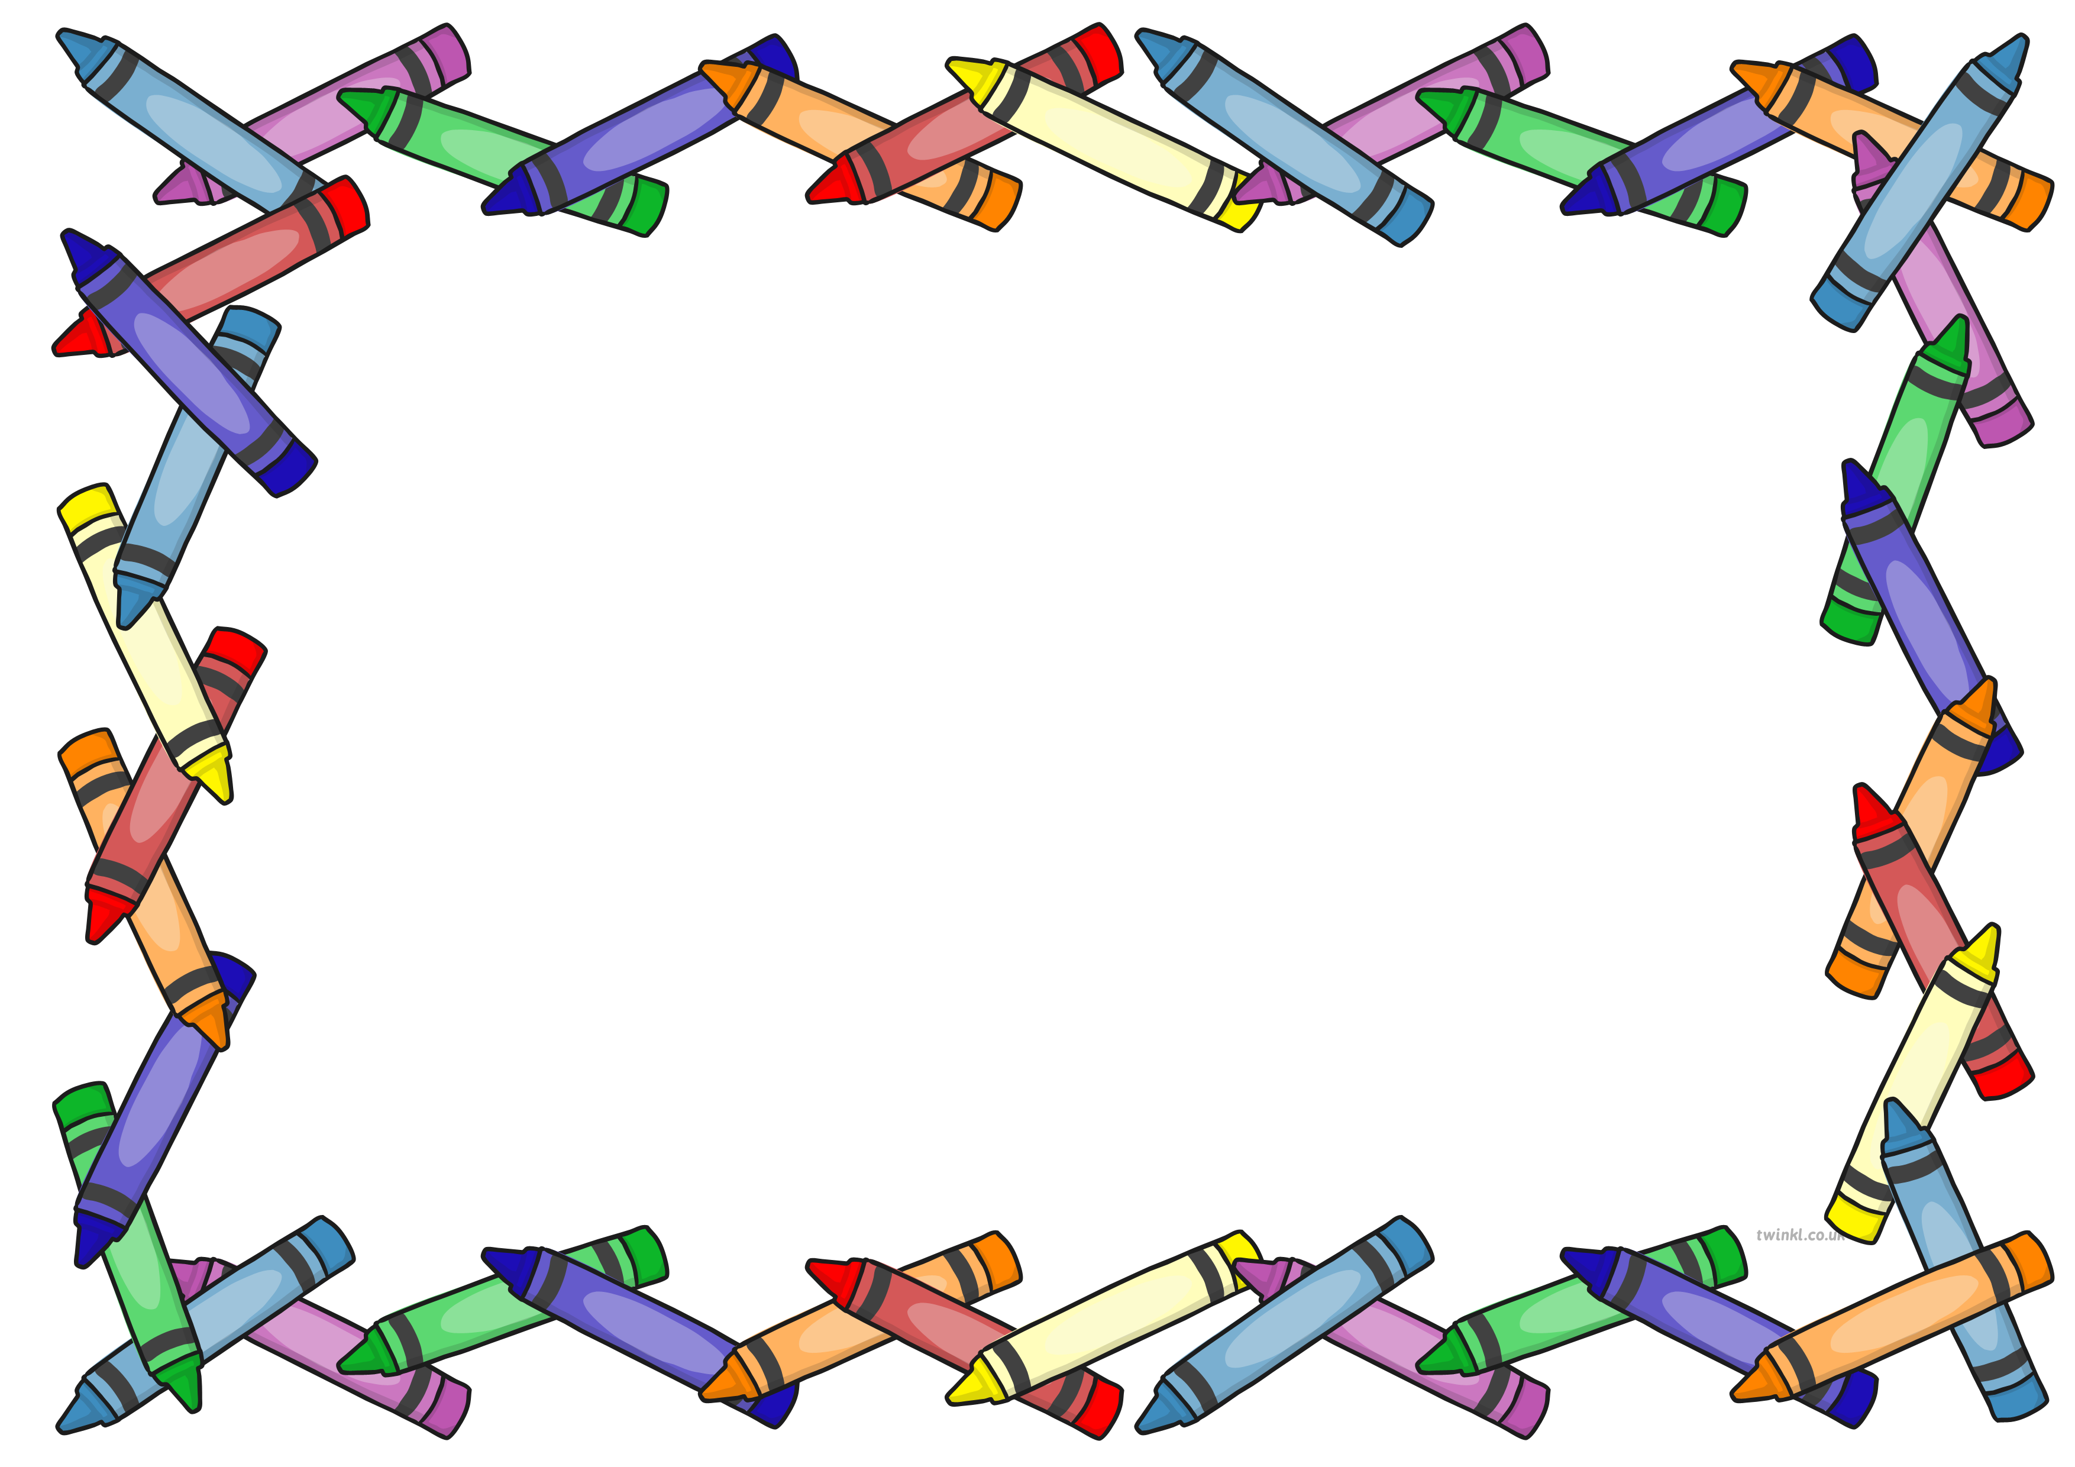
Reception News
Week Beginning: 26th November 2018

This week’s learning…
-Moving like superheroes during a trip to the park.
-Completing superhero missions indoors and outdoors.
-Designing superheroes and writing name labels for them.
-Weighing and ordering superhero objects.
-Searching for magnetic objects using magnetic powers.

At home, encourage your child to…
-Ask each family member what their superhero power would be. Alternatively you could ask them to draw and label each family member as a superhero.
-Hunt for heavy and light objects around the home using their superhero power of strength,
-Make a superhero gadget or vehicle using recycled materials.
Next week we will be…
-Reading the story Supertato.
-Creating and retelling new missions for ‘Supertato’.
-Designing and decorating our own vegetable superheroes.
-Discussing the unkind actions of ‘Evil Pea’ from the story.
-Exploring and playing games with the numbers 11-15.

Notices…
As the weather has taken a rather cold turn, please can you make sure that your child comes to school each day with a jumper, coat, hat and a pair of gloves. The warmer they are, the more they can enjoy their outdoor play ☺.

