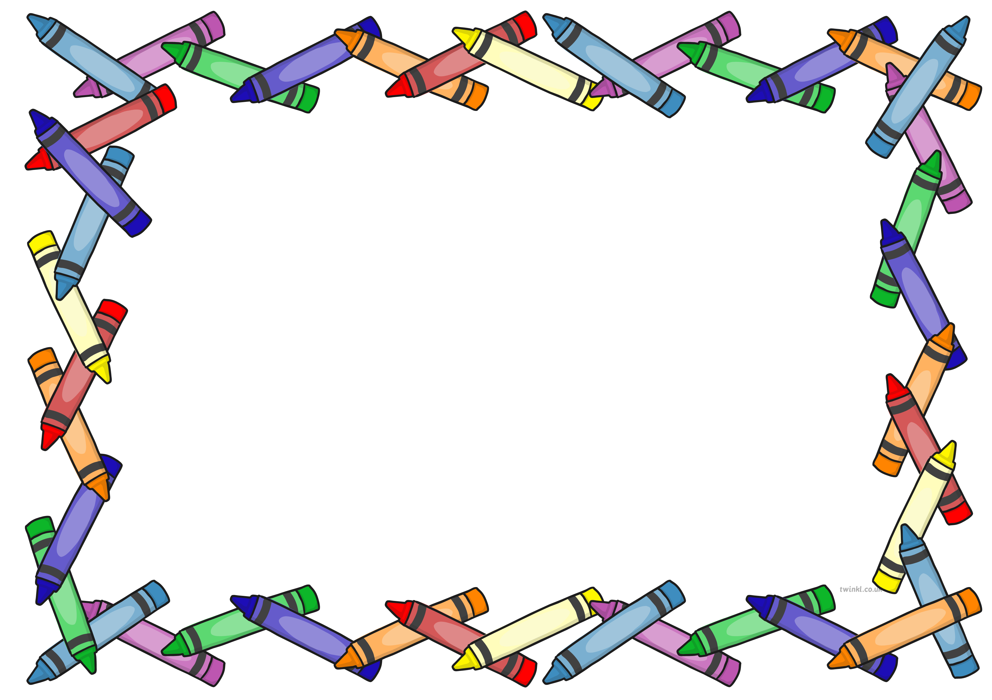
Reception News
Week Beginning: 1st October 2018

This week’s learning…
•Comparing what we could do when we were babies to what we can do now.
•Setting ourselves goals of what we would like to achieve in the future.
•Talking about the jobs we would like to do when we grow up.
•Learning a new shape each day and playing shape games.
•Hunting for shapes in our classrooms and the garden area.
•Recognising the numbers 6-10 and playing lots of games using them.
•Learning the sounds that the letters i, n, p g, o make when we read them.

At home you could encourage your child to…

• Find objects around the home that begin with the letters i, n, o, g, o. E.g. o-o-orange or g-g-gate.
• Make simple cvc words using the letter cards provided in your child’s wallet. E.g. dog, pan, mat, sit.
•Hunt for different shaped objects around the home.
• Look at and discuss baby pictures of themselves and to discuss what they can do now that they are four or five years old.
.

Next week we will be…
•Reading the book ‘Funny Bones’.
•Learning about our own bodies and bones.
•Learning and performing the skeleton dance.
•Following verbal instructions to create short movement routines using our body parts.
•Matching parts of the body with initial letter sounds. E.g. t-t-toes.

Messages…
• Next week and the following week you are invited to a parent consultation session with your child’s class teacher. If you have not already signed up for a 10 minute session, we encourage you to do so. The session is a chance for you to discuss your children’s achievements so far since starting in Reception. We will also be able to answer any questions you may have, including questions about the classroom routines and Reception curriculum.

