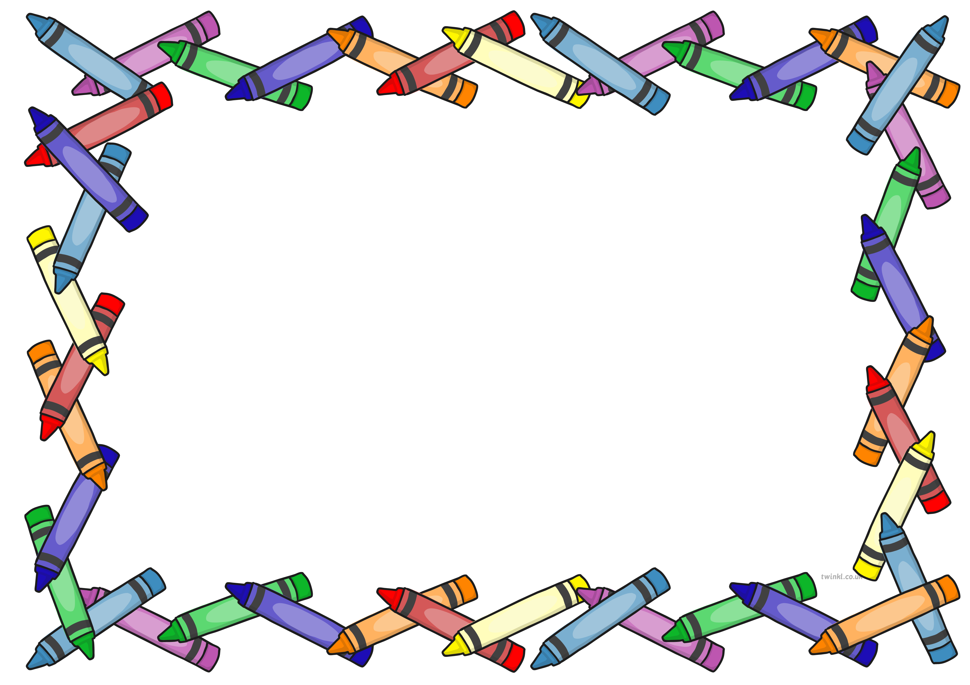
Reception News
Week Beginning: Monday 2nd March

This week’s learning…
-Retelling the story of The Three Little Pigs in groups using words and actions.
-Researching about pigs and presenting our findings.
-Taking part in a Kapla construction session.
-Designing and constructing buildings using our own choice of construction material. E.g. Lego, Stickle Bricks.
-Finding out about the numbers 18, 19 and 20 and using these numbers to play games such as bingo.

At home, encourage your child to…

- Create a poster all about pigs.
- Make models and buildings using resources around the home. They could use recycled materials, tape, pens etc.
- Make a set of number cards using numbers 0-20. You could then play some games with the number cards!
-Count out objects in and around the home. E.g. 10 grapes as a snack or the knives and forks on the dinner table.

Next week…
- Reading the story Little Red Riding Hood.
- Pretending to be characters from Little Red Riding Hood.
- Making ‘Wanted’ posters to describe the big bad wolf.
- Moulding salt dough into food e.g. apples and cakes.
- Carefully painting our salt dough models.
- Making baskets strong enough to make our salt dough models.
- Playing games using numbers 0-20.
- Learning about o’clock times and playing games such as ‘What’s the time Mr Wolf’.
Notices…
-Within the next week, two letters will be sent home. The first invites a special adult of your child’s choice to a Mother’s Day Pampering Afternoon on Friday 20th March and the second invites your child to dress up as their favourite fairy tale character on Friday 27th March.

