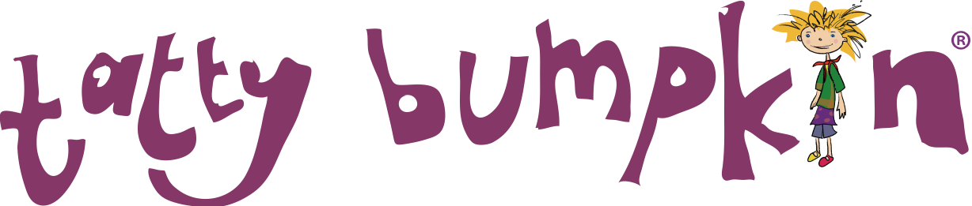
Spring Term 2019

Yoga Inspired Activity Club

Dear Parents,
Tatty Bumpkin After-school sessions will continue on Wednesdays at Monkfield Park Primary School in the New Year starting on 9th January at 3.15pm for 1 hour. All children in reception, Year 1 and Year 2 classes are welcome to join our club.

What is a Tatty Bumpkin class?
Tatty Bumpkin classes take children on a magical journey using yoga positions to tell a unique story every time. They are active sessions and great for sporty children as well as those who enjoy a more creative approach to movement. Each session is fun and motivating encouraging the children to engage in active stories. They will learn new ways to stretch and learn through specifically written songs and moves,
The children will have the opportunity to:
Learn yoga positions that enhance their posture, increase physical strength and ability to learn;
Learn how to relax and deal with everyday anxieties;
Think creatively along with the stories.
The class is inclusive and non-competitive and ideal for boys and girls.
The Tatty Bumpkin programme has been devised by yoga teachers, paediatric physiotherapists, educational and special needs therapists, musicians and children’s authors, and is fully aligned with the Early Years Foundation Stage curriculum.

Why Yoga?
Yoga helps to maintain children’s innate flexibility and develop muscular strength and endurance, providing them with a very different experience and giving variety to their day. Equally important is the fact that yoga improves mental focus, imagination, self-belief and a sense of fun. This serves to build a strong foundation for children to expand their confidence, become aware of their body, and learn new skills. Doing classes together with their friends helps everyone to have fun and releases tension whilst helping them to concentrate on their schoolwork. Please fill out the slip below and return to the School office by 7th January. The classes will be limited to 12 children and are £54.00 for the 12 week term – There is an opportunity to pay ½ termly by paying the first £27.00 on booking and the balance (£27.00) by 13th February. (Cash or cheques need to be made payable to Tatty Bumpkin Cambridge) Your child will be supplied with a poster and stickers to motivate and continue the learning experience at home.
If you would like more information Sue can be contacted on 08456 801436 / 07890141198 or by email:cambridge@tattybumpkin.com ____________________________________________________________________________________________
Name:______________________________________________________ Class:_________________ DOB:___________
Name of Parent/Guardian:__________________________________________________________________________________
Address:________________________________________________________________________________________________
____________________________________________________________ Postcode:___________________________

Contact Number: ______________________________E Mail:______________________________________________________
Any Medical / injuries issues:_________________________________________________________________________________
Signed:___________________________________________________________ Parent/Guardian. Date:___________________

