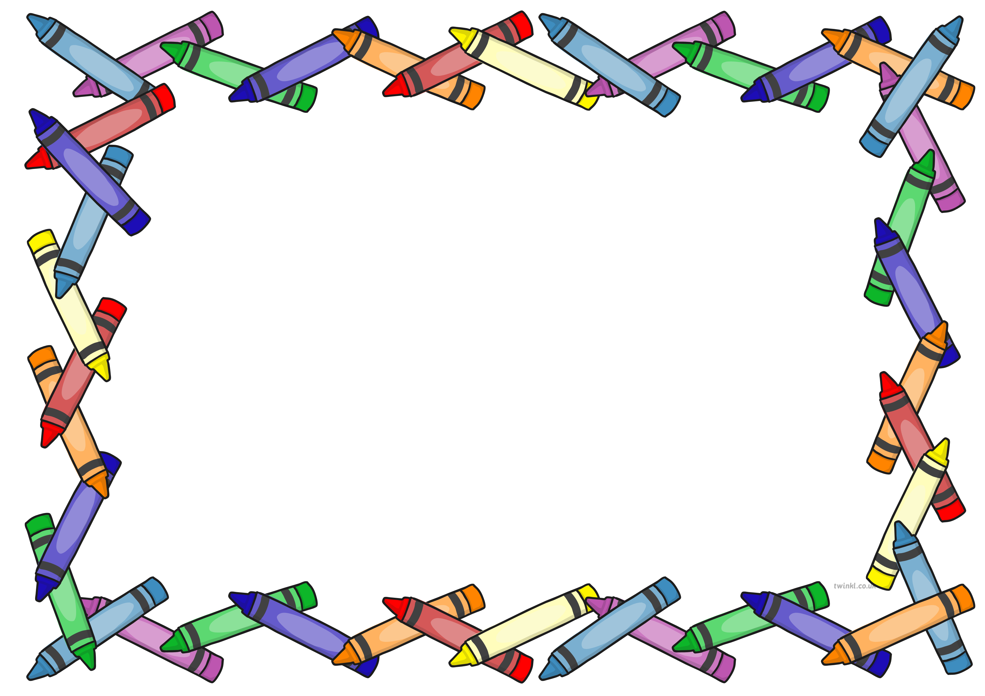
Reception News
Week Beginning: 11th November 2019

This week’s learning…
• Hunting for signs of autumn when on an autumn walk.
• Mixing colours together to create new colours for autumn leaves.
• Matching and comparing amounts using ‘treasure’ objects.
• Practising our bike skills in Balanceability.
• Making inferences and predictions about images in stories.
•Categorising autumn objects by size and colour.
•Collaging autumn pictures with our found objects.

Home Learning…
• Go for a walk or visit the local woodland area and hunt for signs for animals e.g. nests and burrows. They could take some photographs or draw pictures of their findings.
• Research a woodland or nocturnal animal using child friendly websites or non-fiction books from the library.
•To retell you the story of Room on the Broom using words and actions. Alternatively they could draw a sequence of pictures to order the events of the story.
•Tell you how many sounds thay can hear when you bang on a drum or clap or hands for example.
• Draw and write the ingredients they would add to make a magic potion.

Next week…
• Sequencing and retelling the story Room on the Broom
• Using actions to act the story of Room on the Broom
• Learning about the numbers 11 and 12.
• Going on our first school trip to the cinema to watch The Grinch.
• Practising our blending skills during phonics.
• Making materials move in different ways in PE.

- Hunting outdoors for signs of Autumn.
- Drawing our own Autumn inspired pictures.
- Colour mixing and painting Autumn leaves.
- Creating repeating patterns using colours, shapes and objects.

Notices…
• Come and Share is on Thursday afternoon. Please sign up for a slot to view your child’s Learning Journey.

